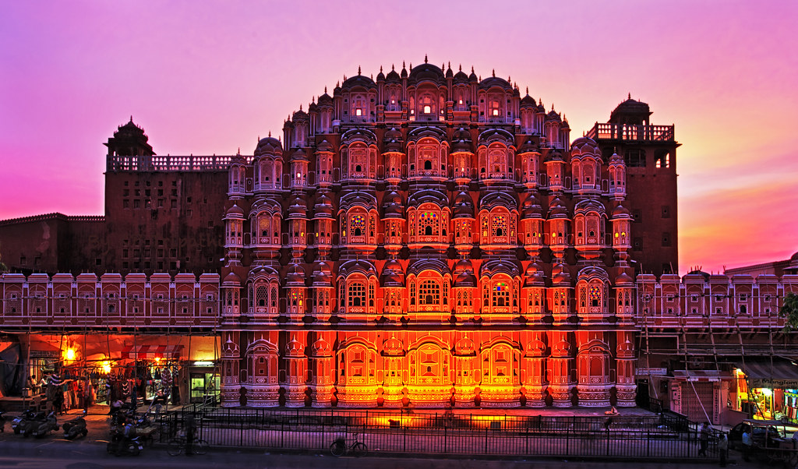
CORPORATE OFFSITE TOUR TO JAIPUR
Delhi – Jaipur – Delhi
Duration: 02 Nights / 03 Days
Travel Dates: 06 – 08 February 2026
Cost Per Person: Rs. 24,031/- per person including of GST @ 5%
Single Room Supplement: INR 10,584 per single

Destination Overview: Jaipur (City of Victory) was founded by Maharaja Sawai Jai Singh II in
1727. It is the only city in the world symbolizing the nine divisions of the Universe through nine rectangular sectors sub-dividing it. The architect who formalized the city’s plans on the Shilpa Shastra, the epic Hindu treatise on architecture, mixed it with the sublimity of the Mughal and Jain influences of those times. The city was painted pink in 1853 in honour of the visit by Prince Albert. Except for the busy traffic of bicycles, cars and buses, little seems to have changed.
.

DAY 01 | 06 FEB 2026 | DELHI – JAIPUR
Distance: 326 kms | Drive Time: Approx. 5–6 hours
07:00 hrs – Departure from Delhi by A/C luxury coach
Begin your journey towards Jaipur by luxury coach through scenic countryside roads,
ideal for informal interactions and team bonding. (Boarding Point to be advised)

09:00 hrs – En-route breakfast at a highway restaurant
10:00 hrs – Re-start the journey towards Jaipur after a lazy breakfast.
13:30 hrs – Arrival at Jaipur & welcome at the resort
Check-in at a nature-surrounded resort offering tranquil surroundings away from city life.
13:00 hrs – Check-in and rooms allocations at hotel Grassfed Resort.
https://www.grassfieldhotelsandresorts.com
13:30 hrs – Lunch at the hotel
15:00 – 17:00 hrs – Leisure time
Relax at the resort or explore the lush surroundings—perfect for unwinding after the drive.
17:00 – 18:00 hrs – Evening Hi-Tea
Light refreshments accompanied by casual indoor activities, encouraging informal team interaction.
18:30 – 21:00 hrs – DJ Night with Bonfire
An engaging evening with music and bonfire and beverages — Ideal for networking and strengthening team connections.
21:00 hrs – Dinner at the hotel
Overnight stay at Corbett

DAY 02 | 07 FEB 2026 | JAIPUR
06:00 – 10:00 hrs – Morning Jeep Safari at JhalanaNatinal Park
Jhalana National Park became a leopard reserve in 2017. The reserve is spread over an area of 20 square kilometers, with immense flora and fauna present in the park. The Jhalana Leopard Safari currently hosts more than 40 leopards and 5 cubs!.

10:30 hrs – Return and breakfast at the hotel
11:30 – 13:30 hrs – Free time & Use of in-house activities at the hotel
Time to relax, interact, in-house activities, or conduct informal discussions in a peaceful natural setting. List of in-house activities: -
13:30 hrs – Lunch at the hotel
15:00 – 17:00 hrs – sightseeing tour:
Visit to Hawal Mahal and walk in Bapu Bazaar.
17:00 – 18:00 hrs – Evening Hi-Tea
A refreshing break before the evening program.
18:30 – 21:00 hrs – DJ Evening with Bonfire & Beverages
Another evening of music, light entertainment, and team camaraderie.
21:00 hrs – Dinner at the hotel
Overnight stay at Corbett

DAY 03 | 08 FEB 2026 | JAIPUR – DELHI
Distance: 275 kms | Drive Time: Approx. 5–6 hours
08:30 hrs – Breakfast at the hotel
10:00 hrs – Check-out from the hotel
10:30 hrs – Departure for Delhi
13:30 hrs – En-route lunch
18:30 – 19:00 hrs – Arrival in Delhi (Deboarding at departure point)
Tour concludes with memorable experiences and refreshed teams

HOTEL DETAILS
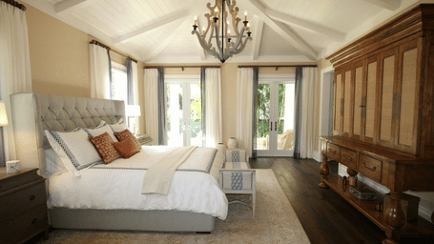
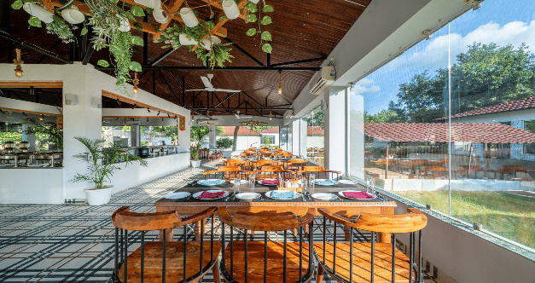
Valley By Grassfield, Jaipur
Stay: 02 Nights

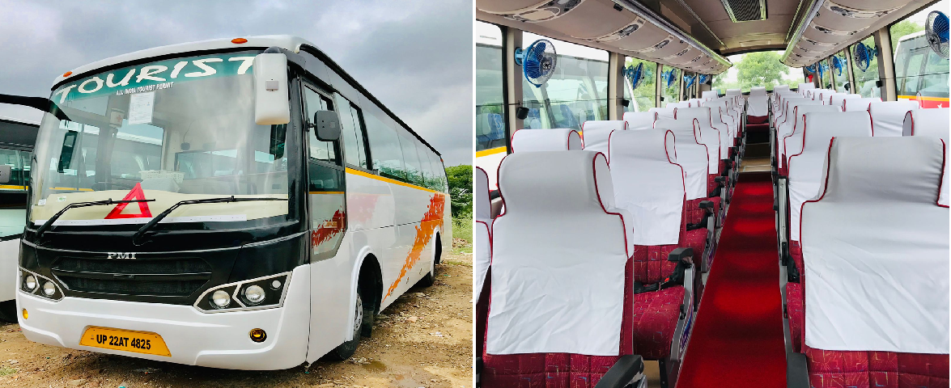

PACKAGE INCLUSIONS

- Accommodation in twin & single rooms
- All meals (Breakfast, Lunch and Dinner) during Stay
- Evening Hi-Tea on both days
- DJ & Bonfire on both the days (2 evenings)
- Alcoholic & Non-alcoholic (IMFL) beverages both the days
- All applicable licenses.
- A/C luxury coach for entire journey
- Jeep Safari on sharing basis (6 pax per Jeep)
- Enroute breakfast from Delhi to Jaipur
- Enroute Lunch from Jaipur to Delhi
- All applicable hotel taxes

PACKAGE EXCLUSIONS
- Tips & gratuities
- In room dining & laundry expenses at hotel.
- Personal expenses
- Any service not mentioned above

